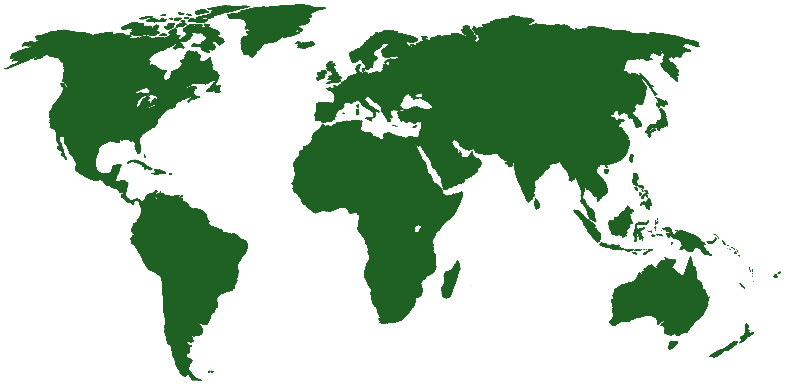
CALL FOR MANUSCRIPTS

Special Issue: Opportunities and Challenges for Growth within the Global Landscape

International Journal of Sustainable Strategic Management

Guest Editors
Bindu J. Vyas and Margarita M. Rose
King's College, Wilkes-Barre, Pennsylvania (USA)

The objective of IJSSM is to “serve as an interface between business leaders, policy makers, economists, and management scholars.” This special issue seeks to compile a collection of papers that can contribute to research issues pertaining to growth and development. Leaders in organizations (public and private, for profit and not for profit) and governments must make responsible strategic and policy decisions that facilitate sustainable growth and development. For sustainable growth and development it is also important that organizational and national resources are managed appropriately.

Manuscripts on the following topics are welcome:
Culture, Governance and Globalization
Policy and Politics
Economics and Health Care
Technology and Social media
Business Adjustments
Choices, Decision-Making and Internationalization

Submission Guidelines
Author Guidelines (PDF Version)
For format and style: http://www.inderscience.com/mapper.php?id=31

Submission
To be considered for publication in this peer reviewed special volume, authors must submit complete manuscripts on or before September 30, 2012 By E-mail to:

Bindu J. Vyas or Margarita Rose
binduvyas@kings.edu mmrose@kings.edu

